# MODULE 4

# ENVIRONMENTAL AUDIT

## ENVIRONMENTAL MANAGEMENT SYSTEM AUDITS

An Environmental Management System (EMS) Audit refers to a systematic and documented verification process of objectively obtaining audit evidence to determine whether an organization’s EMS conforms to the audit criteria and communicating the results of this process to the client.

The objectives of a typical EMS audit include:

* + - Determining conformance of an auditee's EMS with the EMS audit criteria;
    - Determining whether the auditee's EMS has been properly implemented and maintained;
    - Identifying areas of potential improvement in the auditee's EMS;
    - Assessing the ability of the internal management review process to ensure the continuing suitability and effectiveness of the EMS;
    - Evaluating the EMS of an organization where there is a desire to establish a contractual relationship

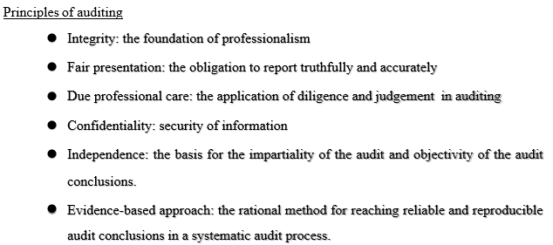

## 4.1.2 STEPS TO BE FOLLOWED IN AUDITING

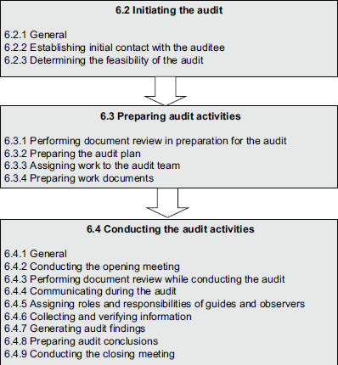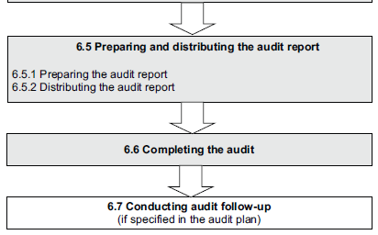

### **Initiating the audit**

When an audit is initiated, the responsibility for conducting the audit remains with the assigned audit team leader until the audit is completed.

* + **Establishing initial contact with the auditee:** The initial contact with the auditee for the performance of the audit can be informal or formal and should be made by the audit team leader.
  + **Determining the feasibility of the audit:** The feasibility of the audit should be determined to provide reasonable confidence that the audit objectives can be achieved.

1. **Preparing audit activities**
   * **Performing document review in preparation for the audit:** The relevant management system documentation of the auditee should be reviewed
   * **Preparing the audit plan:** The audit team leader should prepare an audit plan based on the information contained in the audit program and in the documentation provided by the auditee
   * **Assigning work to the audit team**
   * **Preparing work documents:** The audit team members should collect and review the information relevant to their audit assignments and prepare work documents, as necessary, for reference and for recording audit evidence
2. **Conducting the audit activities**
   * **Conducting the opening meeting**: An opening meeting should be held with the auditee’s management and, where appropriate, those responsible for the functions or processes to be audited
   * **Performing document review while conducting the audit**
   * **Communicating during the audit**: During the audit, it may be necessary to make formal arrangements for communication within the audit team, as well as with the auditee, the audit client, and potentially with external bodies
   * **Assigning roles and responsibilities of guides and observers**: Guides and observers (e.g. regulator or other interested parties) may accompany the audit team
   * **Collecting and verifying information:** During the audit, information relevant to the audit objectives, scope, and criteria, including information relating to interfaces between functions, activities, and processes should be collected employing appropriate sampling and should be verified.
   * **Generating audit findings:** Audit evidence should be evaluated against the audit criteria to determine audit findings.
   * **Preparing audit conclusions**
   * **Conducting the closing meeting:** A closing meeting, facilitated by the audit team leader, should be held to present the audit findings and conclusions.
3. **Preparing and distributing the audit report**
   * Preparing the audit report: The audit team leader should report the audit results by the audit program procedures.
   * Distributing the audit report: The report should be issued within an agreed period.
4. **Completing the audit**

* The audit is completed when all planned audit activities have been carried out, or as otherwise agreed with the audit client.

1. **Conducting audit follow-up**

* The conclusions of the audit can, depending on the audit objectives, indicate the need for corrections, or for corrective, preventive, or improvement actions
  1. **ROLES AND QUALIFICATIONS OF AUDITORS**

EMS auditors should be trained in auditing techniques and management system concepts. Familiarity with environmental regulations, facility operations, and environmental science is a big plus, and in some cases may be essential to adequately, assess the EMS.

As a guidance standard, 14012 can only recommend such qualifications, and the key is to ensure the audit team is familiar with the EMS that they are responsible for, and not all other areas of environmental science or regulations. Secondly, it is understood that no single individual may have all of these qualifications, hence the concept of the audit team

Traits of a good auditor:

* + - Independent (activity being audited)
    - Impartial
    - Tactful
    - Attentive to detail
    - Objective

Auditor responsibilities and activities should cover:

* + - following the directions of and supporting the lead auditor;
    - planning and carrying out the assigned task objectively, effectively and efficiently within the scope of the audit;
    - collecting and analyzing relevant and sufficient audit evidence to determine audit findings and reach audit conclusions regarding the EMS;
    - preparing working documents under the direction of the lead auditor;
    - documenting individual audit findings;
    - safeguarding documents about the audit and returning such documents as required;
    - assisting in writing the audit report
  1. **ENVIRONMENTAL PERFORMANCE INDICATORS AND THEIR EVALUATION**

**Environmental Performance Indicators** provide information that helps evaluation and decision-making within organizations that engage in environmental efforts.

* + - *The first objective* of environmental performance indicators is to measure and evaluate environmental burdens, and environmental problems that need to be solved
    - *The second objective* is to provide a common foundation of information between an organization and interested parties
    - *The third objective* is to provide a common foundation of information for macro-level environmental policies of the national and local governments.

**Types of Environmental Performance Indicators**

ISO standard describes two general categories of indicators for EPE:

* + - Environmental Performance Indicators (EPIs); and
    - Environmental Condition Indicators (ECIs).

There are two types of Environmental Performance Indicators:

* + - Management Performance Indicators (MPIs)
    - Operational Performance Indicators (OPIs)

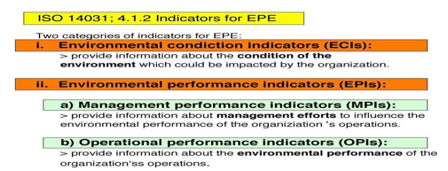

**Management Performance Indicators (MPIs)** relate to the management system and address:

* policy issues and development, e.g. effectiveness of environmental commitments
* resource allocation and purchasing
* human resource issues, e.g. staff training
* planning and practices, e.g. which objectives are being pursued and achieved
* conformance with regulations and audit programs

**Operational Performance Indicators (OPIs)** relate to the performance of operations, including

* Inputs, e.g. energy, materials, utilities, and contractor services
* Through-puts, e.g. design, installation, operation, and maintenance of buildings, materials used, process equipment, and other facilities
* Outputs, e.g. process emissions, trade effluent, emissions to air, solid and liquid

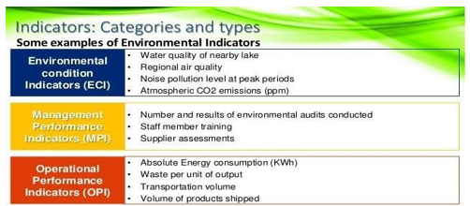

**Examples of performance indicators and metrics**

|  |  |  |
| --- | --- | --- |
| **OPI** | **MPI** | **ECI** |
| The raw material used per unit of  product (Kg/unit) | Environmental costs or budget  ($/yr) | Contaminant concentration in  ambient air (μg/m3) |
| Energy used annually per unit of | Percentage of environmental | Frequency of photochemical |
| product (MJ/1000 L product) | targets achieved (%) | smog events (#/yr) |
| Energy conserved (MJ) | Number of employees trained (% #  trained/to be trained) | Contaminant concentration in  ground- or surface water (mg/L) |
| Number of emergency events or  unplanned shutdowns (#/yr) | Number of audit findings (#) | Change in groundwater level (m) |
| Average fuel consumption of  vehicle fleet (L/100 Km) | Time spent to correct audit  findings (person-hr) | Contaminant concentration in  surface soil (mg/Kg) |
| Hazardous waste generated per unit of product (Kg/unit) | Time spent responding to Environmental incidents (person  hr. / yr.) | The concentration of a contaminant in the tissue of a specific local  specie (μg/Kg) |
| Emissions of specific pollutants  to air (Ton CO2/yr) | Number of complaints from  Public or employees (#/yr.) | Population of an specific species  within a defined area (#/m2) |
| Wastewater discharged per unit of product (1000 L/unit) | Number of suppliers contacted  about environment management. (#/yr) | Fish deaths in a specific watercourse (#/yr) |
| Air emissions were exceeded  (days/yr) | Management levels with specific  environ responsabilities (#) | Employee blood lead levels  (μg/100 mL) |

**Objectives and Benefits of an Environmental Performance Evaluation (EPE)**

1. Better understanding of an organization’s impacts on the environment,
2. Providing a basis for benchmarking management, operational and environmental performance,
3. Identifying opportunities for improving efficiency of energy and resource usage,
4. Determining whether environmental objectives and targets are being met,
5. Demonstrating compliance with regulations,
6. Determining the proper allocation of resources,
7. Increasing the awareness of employees, and,
8. Improving community and customer relations

**Environmental Performance Evaluation** (EPE)

**Environmental Performance Evaluation** (EPE) is “an internal process and management tool designed to provide management with reliable and verifiable information on an ongoing basis to determine whether an organization’s environmental performance is meeting the criteria set by the management of the organization”.

Environmental Performance Evaluation (EPE) is an internal management process that uses indicators to provide information comparing an organization’s past and present environmental performance with its environmental performance criteria.

**EPE, as detailed in this International Standard, follows a “Plan-Do-Check-Act” management model.**

The steps of this ongoing process are the following:

1. **Plan**
   * planning EPE;
   * selecting indicators for EPE
2. **Do:** Using data and information which includes:
   * collecting data relevant to the selected indicators;
   * analyzing and converting data into information describing the organization’s Environmental performance;
   * assessing information describing the organization’s environmental performance in comparison with the organization’s environmental performance criteria;
   * Reporting and communicating information describing environmental performance.
3. **Check and Act**: Reviewing and improving EPE.

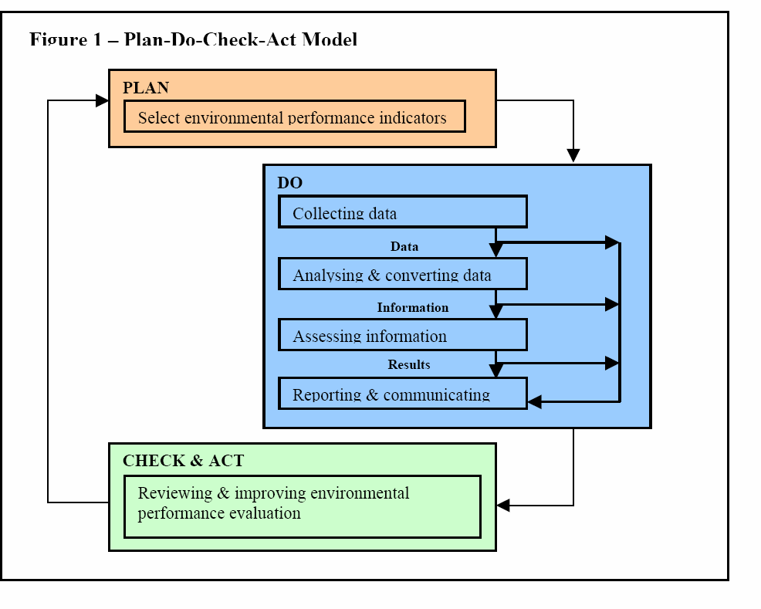

* 1. **NONCONFORMANCE – CORRECTIVE AND PREVENTIVE ACTIONS**

No EMS is perfect when system deficiencies are encountered organization will need a process to ensure that:

* + - Problems including nonconformities are investigated;
    - Root causes are identified;
    - Corrective actions are identified and implemented; ,
    - Corrective actions are tracked and documented.

EMS nonconformities and other system deficiencies should be analyzed to detect patterns or trends. Identifying these trends will allow you to anticipate and prevent future problems.

“**Root cause analysis**” is a process by which you can identify causes and preventive actions. Example: If a spill occurs several times in your raw material transfer area, you would attempt to identify the root cause of the spill occurring so that you could address the cause and prevent the spill in the future

* + 1. **What is a Major Non-Conformance?** A deficiency that seriously impairs the effectiveness of the EMS Examples:
       - An element of ISO 14001 not implemented
       - Procedures not developed or not implemented
       - Failure to take corrective or preventive action
       - Several minor non-conformances
    2. **What is a Minor Non-Conformance?**

A minor deficiency that does not seriously impair the effectiveness of the EMS Examples:

* + - * One or a few individuals (out of many) do not use a procedure correctly
      * Procedure needs minor changes to be effective.
      * One or a few records incomplete
    1. **What are Corrective and Preventive Actions?**
* Corrective action fixes the immediate problem (e.g., repair a leaking valve)
* Preventive action is designed to stop the problem from occurring again or stop problems before they happen (e.g., improved maintenance procedures).
* Effective preventive actions are key to CONTINUAL IMPROVEMENT.

ISO 14001 Non-Conformance, Corrective and Preventive Action says:

The organization shall establish and maintain procedures for defining responsibility and authority for handling and investigating nonconformance, taking action to mitigate any impacts caused, and initiating and completing corrective and preventive action.

* + 1. **Steps to Identify and Correct Non-Conformance**
* Identify problems through routine inspection, monitoring, audit findings, trend analysis, employee comments, complaints, experience
* Investigate the problem and its underlying causes. Involve persons with first-hand knowledge of the issues, and authority to achieve solutions
* Identify the best solution(s) and the persons responsible for implementing them
* Ensure the solution is adequate for the size and nature of the problem, i.e., fix the underlying cause(s) once and for all
* Follow-up with monitoring to confirm that the implemented solution is effective long term
* Involve people throughout with sufficient influence to ‘make things happen’ promptly
  + 1. **Non-Conformance Investigation Example**

PROBLEM:

* Environmental monitoring results not submitted to the government on time Possible underlying causes:
* Responsibility for reporting not clearly communicated
* Inadequate training or awareness of reporting schedule requirements
* Written procedure not available
* Insufficient supervision and checking Principles of Corrective and Preventive Action
* Don’t ignore problems and hope they’ll go away
* Ask: Who? What? When? How? Where? WHY? until you arrive at the root cause of the problem
* Fix deficiencies in the system, not just symptoms of the problem
  1. **COMPLIANCE AUDITS**

An Environmental Compliance Audit is an investigation of the compliance status of a facility and/or the extent of environmental liability. This process is a systematic, documented evaluation of a facility, focusing on current operating and administrative procedures and processes.

An environmental compliance audit can also be used to determine whether an existing environmental management system is effective:

* + - maintaining compliance
    - identifying deficiencies
    - taking corrective actions
* Environmental compliance audits are thorough inspections and reviews of facilities to ensure a company or site is meeting environmental regulations.
* An environmental compliance audit may include a review of compliance with local, state, or federal rules as well as internal company policies.
* A regulatory compliance audit may incorporate all media, including air, soil, water, energy, noise and waste. Or the scope may consist only of an environmental site assessment for one regulated area, such as soil.
* Each audit is custom-designed for an individual facility to ensure environmental regulation compliance specific to that site.
* An environmental compliance audit allows a company to identify and address any existing or potential environmental issues before they become legal issues or lead to regulatory fines and penalties.
* Educating the company’s staff on environmental compliance is also a part of the audit.
* Environmental compliance audits focus on a company’s operations and systems. A customized, detailed checklist-type protocol is typically used to conduct the audit.
* Environmental compliance consulting also may include questionnaires, site visits, records reviews, interviews with staff, and comprehensive facility inspections and compliance reviews.
  1. **COMPLIANCE AUDITS**

An Environmental Compliance Audit is an investigation of the compliance status of a facility and/or the extent of environmental liability. This process is a systematic, documented evaluation of a facility, focusing on current operating and administrative procedures and processes.

An environmental compliance audit can also be used to determine whether an existing environmental management system is effective:

* + - maintaining compliance
    - identifying deficiencies
    - taking corrective actions
* Environmental compliance audits are thorough inspections and reviews of facilities to ensure a company or site is meeting environmental regulations.
* An environmental compliance audit may include a review of compliance with local, state, or federal rules as well as internal company policies.
* A regulatory compliance audit may incorporate all media, including air, soil, water, energy, noise and waste. Or the scope may consist only of an environmental site assessment for one regulated area, such as soil.
* Each audit is custom designed for an individual facility to ensure environmental regulation compliance specific to that site.
* An environmental compliance audit allows a company to identify and address any existing or potential environmental issues before they become legal issues or lead to regulatory fines and penalties.
* Educating the company’s staff on environmental compliance is also a part of the audit.
* Environmental compliance audits focus on a company’s operations and systems. A customized, detailed checklist-type protocol is typically used to conduct the audit.
* Environmental compliance consulting also may include questionnaires, site visits, and records reviews, interviews with staff, and comprehensive facility inspections and compliance reviews.
* Conducting a compliance audit not only lowers the risk of violating environmental regulations but also demonstrates a company’s commitment to continually improving the environment
  1. **WASTE AUDITS**
     + A waste audit is a physical analysis of waste composition to provide a detailed understanding of problems, identify potential opportunities, and give you a detailed analysis of your waste composition.
     + A waste audit is a thought-out process that is used to determine the amount and types of waste produced by a company.
     + Organizations conduct waste audits to minimize the organization's waste impact on the environment. Organizations conduct waste audits voluntarily and as mandated by local, state, and federal laws.

A waste audit will help the organization to clearly, identify their waste generation to:

* + - Establish baseline or benchmark data.
    - Characterize and quantify waste streams.
    - Verify waste pathways.
    - Identify waste diversion opportunities.
    - Identify source reduction opportunities.
    - Assess effectiveness and determine ways to improve the efficiency of your current waste management systems.
    - Gain specific information for local government accreditation.
    - Obtain detailed data on waste generation.
    1. **Process of Waste Audit:**
* A waste audit is a process used to calculate the type and amount of waste generated by an organization. Any size organization can perform this type of audit.
* The data collected from the audit will identify the type of waste produced by the organization and how the organization manages this waste. The audit can also make the organization more effective at reducing waste management costs by educating staff about proper waste disposal and making better use of natural of waste produced by a company.

**Validating the Data**

* Once the organization receives the data from a waste audit, the organization must validate the data. The company must ensure that the data collected during this process is sample representative. Additionally, the data must consider the organization over time.
* If the organization had previous waste audits, the organization should compare the data from the present waste audit to the data previously generated.
* Once the organization successfully validates the data and makes sure the data is representative of the habits of the organization, the organization can take measures to make changes to waste management procedures.

**Implementation**

* Organizations may choose to implement aspects of the waste audit with the help of different environmental agencies such as the Environmental Protection Agency or various state and local agencies.
* Environmental agencies have many resources that the organization can use to make the implementation process more effective. Each organization has specific waste management needs, but reduction, collection and recycling are common tools used by organizations during the implementation process.

**Monitoring and Reviewing**

* In many cases, the initial excitement of performing and implementing these audits does not last long. A monitoring and review process performed weekly, bi-monthly or monthly by the organization can help to ensure the long-term success of changes to waste management policies.
* Typically, organizations will create a waste team responsible for this monitoring and review process. Additionally, rotating the team members involved in the monitoring and review process will discourage complacency and encourage organization-wide participation in waste management changes.
  1. **WASTE AUDITS**
     + A waste audit is a physical analysis of waste composition to provide a detailed understanding of problems, identify potential opportunities, and give you a detailed analysis of your waste composition.
     + A waste audit is a thought-out process that is used to determine the amount and types of waste produced by a company.
     + Organizations conduct waste audits to minimize the organization's waste impact on the environment. Organizations conduct waste audits voluntarily and as mandated by local, state and federal laws.

A waste audit will help organization to clearly, identify their waste generation to:

* + - Establish baseline or benchmark data.
    - Characterize and quantify waste streams.
    - Verify waste pathways.
    - Identify waste diversion opportunities.
    - Identify source reduction opportunities.
    - Assess effectiveness and determine ways to improve efficiency of your current waste management systems.
    - Gain specific information for local government accreditation.
    - Obtain detailed data on waste generation.
    1. **Process of Waste Audit:**
* A waste audit is a process used to calculate the type and amount of waste generated by an organization. Any size organization can perform this type of audit.
* The data collected from the audit will identify the type of waste produced by the organization and how the organization manages this waste. The audit can also make the

organization more effective at reducing waste management costs by educating staff about proper waste disposal and making better use of natural of waste produced by a company

**Validating the Data**

* Once the organization receives the data from a waste audit, the organization must validate the data. The company must ensure that the data collected during this process is sample representative. Additionally, the data must consider the organization over time.
* If the organization had previous waste audits, the organization should compare the data from the present waste audit to the data previously generated.
* Once the organization successfully validates the data and makes sure the data is representative of the habits of the organization, the organization can take measures to make changes to waste management procedures.

**Implementation**

* Organizations may choose to implement aspects of the waste audit with the help of different environmental agencies such as the Environmental Protection Agency or various state and local agencies.
* Environmental agencies have many resources that the organization can use to make the implementation process more effective. Each organization has specific waste management needs, but reduction, collection and recycling are common tools used by organizations during the implementation process.

**Monitoring and Reviewing**

* In many cases, the initial excitement of performing and implementing these audits does not last long. A monitoring and review process performed weekly, bi-monthly or monthly by the organization can help to ensure the long-term success of changes to waste management policies.
* Typically, organizations will create a waste team responsible for this monitoring and review process. Additionally, rotating the team members involved in the monitoring and review process will discourage complacency and encourage organization-wide participation in waste management changes
  + 1. **Waste Minimization Planning**

Waste minimization can be defined as "systematically reducing waste at source". It means:

* Prevention and/or reduction of waste generated
* Efficient use of raw materials and packaging
* Efficient use of fuel, electricity and water
* Improving the quality of waste generated to facilitate recycling and/or reduce hazard
* Encouraging re-use, recycling and recovery

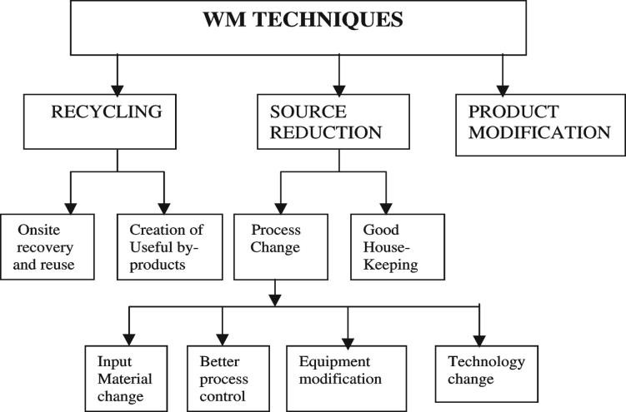

The following are the techniques:

1. **Waste Reduction at source** – this can be achieved by changing or modifying of production process and/or equipment used, with assurance that product quality is not affected.
   * **Product or raw materials substitution** involves the substitution of raw materials with of less toxic substances and can produce the same product quality but of fewer residual unwanted by-products.
   * **Process change, modification, and control** include the use of the latest technology involving new equipment or the process itself. Its application, however, is process-specific and shall be carefully studied before being implemented for the selection of the best and the most acceptable alternatives.
   * **Good housekeeping practice** is the key aspect in keeping a waste minimization program a success and has a minimum capital requirement and yet provides the highest return on investment. This can be easily accomplished through awareness programs & campaigns of company staff on the benefits of waste generation and its control. This includes proper

waste segregation & waste classification to determine its quality, proper storage, and determining its value or usability. On the part of the management, regular waste audits for reconciling what goes in and what is out are useful tools in determining the overall benefits of good and realistic housekeeping programs.

1. **Waste Re-Use and Recycling** – is the practice of recovering usable components of a declared waste for subsequent use in other purposes or sale either with or without pre-treatment. Generally, recycled materials can either be used in the same service from which it was generated or in entirely different premises, activities, or purposes with consideration of possible misuse, its effect, and the efficiency and safety of the receiver or user.
2. **Treatment of Waste** – eliminates the toxic content of the waste stream, reduces the risk of pollution and the health of the public, and increases its acceptability for discharge into the environment for its intended use. This also provides an incentive to the user as it enhances the quality of waste and increases the potential for recycling.

**Benefits of Waste Minimization Practice:**

Waste minimization practices benefit not only the company or the waste generator but the government regulatory agency as well. This includes:

* + Increase production, but lessen waste generation;
  + Saving money by reducing waste treatment & disposal costs, raw material purchases, and other operational costs including storage;
  + Optimize use of resources (like water);
  + Enhance public and worker's health and safety;
  + Improve environmental performance, regulatory compliance & meeting to any national waste minimization goals;
  + Extend the useful life of landfills and disposal sites;
  + Reduce potential environmental liabilities; and
  + Promotes good public image on environmental protection.
  1. **DUE DILIGENCE AUDIT**

Due diligence is the investigation or exercise of care that a reasonable business or person is expected to take before entering into an agreement or contract with another party.

**Due diligence** is an investigation or **audit** of a potential investment or product to confirm all facts, such as reviewing all financial records, plus anything else deemed material. It refers to the care a reasonable person should take before entering into an agreement or a financial transaction with another party.

A Process used to identify environmental problems associated with a piece of property before purchase. The scope of property transfer assessments often is much broader and focuses more on business risks and liabilities as opposed to regulatory compliance.

Enforcement and Compliance History Online (ECHO)

A web-based tool that provides access to compliance and enforcement for opportunity 800,000 EPA-regulated facilities. ECHO allows users to find permit, inspection, violation, enforcement action, and penalty information covering the past two years. The data in ECHO are updated monthly.

Effects

Refers to changes, actual or potential, caused by a chemical, activity, or process as it comes into contact with humans or the environment.

Effluent

Any gaseous or liquid waste fluid emitted by a source. A discharge from an exit is relatively self-contained, such as an industrial smokestack or a sewage treatment plant. Often referred to as the source of pollution or pollution itself, pollutant discharges into water

Emergency response

Responses to incidental releases of hazardous substances where the substances can be absorbed, neutralized, or otherwise controlled at the time of release by employees in the immediate release area, or by maintenance personnel are not considered to be emergency responses within the scope of this standard. Responses to releases of hazardous substances where there is no potential safety or health hazard (i.e., fire, explosion, or chemical exposure) are not considered to be emergency responses.

Environmental Due Diligence (EDD) is the assessment and management of environmental liabilities and risks.

* Environmental Due Diligence is both a legal and technical exercise – an action of analyzing your organization’s site or a site your organization is looking to acquire. It is often demonstrated by a formal assessment of the organization and land to identify any existing or previous environmental conditions and/or contaminations and quantify financial and legal risks.
* The environmental assessment which is a part of a due diligence process mainly aims at identifying any claims or liabilities generated by environmental degradation, such as potential soil and groundwater contamination resulting from current or historical activities performed on the site which is subject to the transaction process.
* Also, another objective of environmental due diligence (EDD) is the estimation of associated remediation costs, which may affect the closing of the transaction; if such costs are identified, they can serve as an efficient negotiation tool for the parties involved in the transaction and they can ultimately be turned into commercial advantages.
  1. **ENVIRONMENTAL STATEMENT: FORM 5**
     + In today’s world every industry is optimizing its Sources, equipment, and processes to face increasing competition and are forced to minimize Environmental pollution. There is a need for pressure on pollution-contributing industries to optimize their production by improving production technologies.
     + Environmental statement is the self-inspection process for improvement in processes and reduction in waste over the last year.
     + The only mandatory process in the Environmental Statement is to fill up Form V and submit it to the Pollution Control Board. If you notice Form V there are fields where the industry needs to put their last year’s Numbers with Current Year's Numbers to identify where they stand.

**4.8.1 Environmental Statement Submission Date**

* Notification for Environmental Statement form V Published on 28 Apr 1992 by Ministry of Environment and Forest. As per the act (Water, Air, and Hazardous Waste), every industry should submit an environmental statement for the financial year ending (i.e. 31st Mar) to the concerned state pollution control board.

Information Collected through Environmental Statement Form V

In the environmental statement, every industry should provide information on the production, and consumption of raw, water, pollutants discharged in the environment, and solid and hazardous waste with their treatment processes.

Important things to be reported to the pollution control board are:

* if that company is reusing its by-products or waste material which results in a reduction in consumption of air, water or energy
* production cost
* additional investment proposals for environmental protection i.e. gradation, improvement in process, or new equipment to reduce environmental pollution.
  + 1. **Environmental Statement Form V Filling Process**

There are a total of Nine Sections in Environmental Statement Form V.

* **Part A** Basic information about the company like name, address, industry category, production capacity, and date of last environmental audit submitted.
* **Part B** This part is for comparison of water and raw material consumption for this financial year to the previous year.
* **Part C** This part is to measure pollutants discharged to the environment through medium air and water. How much in excess, an industry is releasing pollutants into the environment?
* **Part D** This part measures hazardous waste from processes and pollution control facilities
* **Part E** This part is to measure solid waste generated by industry. Also details like quantity recycled, sold, and disposed
* **Part F** Any new practices adopted to reduce hazardous waste.
* **Part G** Impacts of pollution control measures on natural resources and with cost of production.
* **Part H** Additional investment/process/measures to minimize or prevent pollution.
* **Part I** In this part other information/initiatives to improve the quality of the environment need to be given.

Whenever Part C, indicates high variation then Part H (i.e. additional investment proposals for environmental protection including abatement of pollution) should be taken more seriously

**ANNEXURE**

**ENVIRONMENTAL STATEMENT FORM-V**

**(See rule 14)**

*Environmental Statement for the financial year ending on 31st March 2016*

***PART-A***

* + - 1. *Name and address of the owner/* Naveen Kumar Singh, Director In-charge

*occupier of the industry operation* Jaypee Cement Corporation Limited,

*or process.* Shahabad Cement Plant, Village- Bankur,

Tal- Chittapur, Dist. - Kalaburagi

* + - 1. *Industry category Primary-(STC Code) Secondary- (STC Code)*
      2. *Production category.*

|  |  |  |  |
| --- | --- | --- | --- |
| Sl No | Product | Unit of Measurement | Quantity |
| 1 | Cement | Million tons per Annum | 2.4 (Installed capacity) |
| 2 | Ele Power | MW | 60 (Installed capacity) |

* + - 1. *Year of establishment* May 2012
      2. *Date of the last environmental statement submitted.* NA

***PART-B***

*Water and Raw Material Consumption:*

1. *Water consumption in m3/d*

|  |  |
| --- | --- |
| *Process:* | 5710 |
| *Cooling:* | 700 |
| *Domestic:* | 290 |

|  |  |  |
| --- | --- | --- |
| Name of Products | Process water consumption per unit of products | |
| During the previous financial year 2014 - 2015 | During the current financial Year 2015 - 2016 |
| Cement | NA | 0.31 m3/ T |
| Ele Power | NA | 0.141 L/ kWh |

1. *Raw material consumption*

|  |  |  |  |
| --- | --- | --- | --- |
| Name of Raw materials | Name of Products | Consumption of raw material per unit of output | |
| During the previous financial year 2014 -15 | During the current financial Year 2015 -16 |
| Clinker | Cement | 0.7 T / T | 0.73 T / T |
| Flyash | 0.28 T / T | 0.24 T / T |
| Gypsum | 0.03T / T | 0.03 T / T |
| Coal | Ele Power | 0.0 T / MWh | 0.00105 T / kWh |

*\* Industry may use codes if disclosing details of raw material would violate contractual obligations, otherwise, all industries have to name the raw materials used.*

***PART-C***

***Pollution discharged to environment/unit of output***

*(Parameter as specified in the consent issued)*

* 1. Water

|  |  |  |  |  |
| --- | --- | --- | --- | --- |
| Pollutants | Quantity of Pollutants discharged (mass / day) | Quantity of Pollutants discharged  (mass / Volume) | Tolerance limit specified by KSPCB  (Mass / Vol) | Percentage of variation from prescribed  standards with reason |
| pH | - | 7.61 | 5.5 to 9 |  |
| Suspended | 8.27 kg/day | 8 mg/l | 100 mg / l |  |
| Solids Max |  |
| Oil & | - | ND | 10 |  |
| Grease |  |
| Temp | - | Nil | Maximum |  |
| 5⁰C higher  than intake | All parameters |
| temp | are maintained in |
| Dissolved | 427 kg/day | 413 mg/l | 2100 mg / l | tolerance |
| solids | Max | limit specified, |
| (Inorganic) |  | as per CFO |
| Chlorides | 59.29 kg/day | 51.18 mg/l | 1000 mg / l |  |
| (As Cl) | Max |  |
| Dissolved | 0.058 kg/day | 0.056 mg/l | 5 mg / l Max |  |
| Phosphates |  |
| (As P) |  |
| Sulphate | 52.15 kg/day | 50.43 mg/l | 1000 mg / l |  |
| (As SO4) | Max |  |

* 1. Air

|  |  |  |  |  |
| --- | --- | --- | --- | --- |
| Pollutants | Quantity of Pollutants discharged (mass/day) | Quantity of Pollutants discharged (mass / Volume) | Tolerance limit specified by KSPCB  (Mass / Vol) | Percentage of variation from prescribed Standards with reason |
| PM | 191 kg/day | 17 mg/Nm3 | 50 | Maintained as per tolerance limit |
| SO2 | 618 kg/day | 55 mg/Nm3 | 100 |
| NO2 | 2881 kg/day | 257 mg/Nm3 | 800 |

***PART-D***

***HAZARDOUS WASTES***

*(As specified under Hazardous Wastes (Management & Handling Rules,1989).*

|  |  |  |
| --- | --- | --- |
| Hazardous Wastes | Total Quantity (kg) | |
| During the previous financial year 2014-15 | During the current financial Year 2015-16 |
| From Process |  | |
| Used oil | NA | 600 |
| From Pollution Control Facilities | NA | NA |

***PART- E***

***SOLID WASTES****:*

|  |  |  |
| --- | --- | --- |
| Solid Wastes | Total Quantity (kg) | |
| During the previous  financial year 2014-15 | During the current financial  Year 2015-16 |
| From Process |  |  |
| Bottom Ash | NA | 13,92,000 |
| Flyash | NA | 6,82,08,000 |
| Sludge | NA | 10,40,000 |
| From Pollution control Facilities | NA | Bag filters’ dust collection is reused in production |

***PART - F***

*Please specify the characteristics (in terms of concentration and quantum) of hazardous as well as solid wastes and indicate disposal practices adopted for both these categories of wastes.* **Please refer Annexure A** to Form V

***PART- G***

*Impact of the pollution control measures taken on conservation of natural resources and consequently on the cost of production.* **Please refer Annexure B** to Form V

***PART - H***

*Additional measures/investment proposal for environmental protection including abatement of pollution.*

***PART - I MISCELLANEOUS:***

*Any other particulars in respect of environmental protection and abatement of pollution.*

**Annexure A**

to Form V

**PART F** (Please specify the characteristics (in terms of concentration and quantum)

of hazardous as well as solid wastes and indicate disposal practices adopted for both these categories of wastes.)

1. Following **hazardous waste** from the plant is disposed of safely, according to recommended practices without any nuisance to the environment.

|  |  |  |  |  |
| --- | --- | --- | --- | --- |
| Sl No | Name | Quantity per year | Storage & transport | Disposal method |
| 1 | Used Oil | 600 kg | Area earmarked,  Stored in drums | Consumed in the boiler with coal |
| 2 | Used lead acid batteries | 15 Nos | Ear-marked Storage area | Sold back to battery dealer (Authorized) |

1. Other **solid wastes** are disposed in scientific manner to maintain clean and hygienic environment inside the plant and colony area.

|  |  |  |  |  |
| --- | --- | --- | --- | --- |
| Sl No | Name | Quantity per year | Storage & transport | Disposal method |
|  |  |  | It is collected at the boiler and | From silo, it is pumped by |
| 1 | Bottom Ash | 13.92 T | transported pneumatically | dense phase conveying |
|  |  |  | to Silo | system for PPC production |
| 2 | Fly ash | 68208 T | It is collected in ESP hoppers and transported pneumatically to Silo | in cement mill. Surplus quantity is sold to nearby  cement plants through bulkers |
| 3 | Sludge | 1040 T | Stored in landfill | Used as manure in horticulture |
| 4 | Metal/ Wood/paper | 5.5T/  18.25 T | Ear-marked Storage area | Sold to the scrap dealer |
| 5 | Garbage | 36 T | Dust bins in the colony area | Garbage is collected by the Notified area Committee. |

**Annexure B**

to Form V

**PART G** (Impact of the pollution control measures taken on conservation of natural resources and consequently on the cost of production.)

Water is a very scarce commodity, and maximum efforts are made to conserve it. One of the important technologies installed in the captive power plant is “Air-cooled

Condensers” in the place of conventional water-cooled condensers. This facilitates our plant to save water loss due to evaporation in the cooling tower. The total investment for an Air-cooled condenser is ₹ 16 crore.

Due to the use of an Air-Cooled Condenser in the power plant, there is a saving in water consumption to the tune of 5000 m3/ day.